# **Caremark.com – Troubleshoot Standard Registration Sign Up Website**

|  |
| --- |
| **“We Need Something From You” Error** |

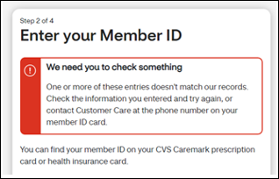

A member’s first and last name must be entered as it is shown in Compass.

**Examples:**

* First name and middle initial may be shown as part of the first name in Compass. Try entering the first name and middle initial in the **First Name** field.
  + Jane C
* Hyphen or suffix in the last name. Enter the hyphen or suffix in the **Last** **Name** field.
  + Smith-Jones
  + Smith Jr (Additional suffix examples: Sr, II, III etc.)

|  |
| --- |
| **Delay In Receiving Email or Text Alert with MFA Verification Code** |

In some instances, there may be a delay with receiving the verification code before it expires within 30 minutes after it is requested depending on volume of alerts being sent.

Workaround for Customer Care to assist members and provide the member with the code:

 You **CANNOT** utilize this workaround **unless:**

* The member has been fully authenticated with 4 authentication elements per the [Web Support HIPAA Guidelines](https://thesource.cvshealth.com/nuxeo/thesource/#!/view?docid=29c145e4-abda-481c-a24e-f3fd72145dbb).
  + If assisting another individual on the member’s behalf, you **MUST** speak to the member/beneficiary themselves (unless Power of Attorney (POA) OR Appointment of Representative (AOR) is in effect or member verbally authorizes at the time of the call to speak with someone else). Refer to the HIPAA Authentication Grid.

View the last email or text alert sent within the last 30 minutes by:

1. Navigating to the Compass Quick Access panel
2. Select Communications,
3. Select Digital Communications
4. Provide the member with the code to enter and login with.

|  |
| --- |
| **Already Registered** |

After Verifying the member is not already registered in Compass, if the member receives this “Already Registered” error message, submit a [Web Error Form](https://thesource.cvshealth.com/nuxeo/thesource/#!/view?docid=43ed6e8a-7e44-4cab-9831-eac9b6f67e7b).

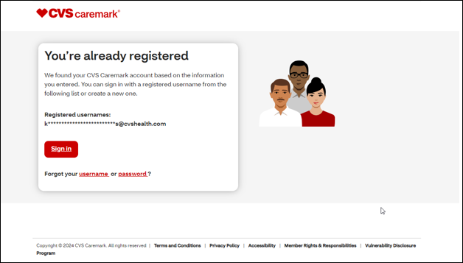

|  |
| --- |
| **Troubleshoot Registration Sign Up** |

1. Ask the member for the ID number on their member card.

* Member may need to exclude the letters that are displayed at the beginning of their ID number.

1. Review Compass to determine if it matches the Member ID number (External/Alternate ID) that is shown in Compass from the Eligibility tab.

* No, order a new card for the member if Caremark provides the ID Cards. Refer to the appropriate CIF for additional information.
* As an immediate work-around, suggest that the member can select “[PersonalInformation](https://thesource.cvshealth.com/nuxeo/thesource/#!/view?docid=3d8135d2-1892-464a-aa80-61a2d1ae3146)” and proceed to enter their personal information and answer a few demographic questions.

1. If the member is unable to enroll using personal information, and the troubleshooting process does not resolve the situation, submit a [Web Error Form](https://thesource.cvshealth.com/nuxeo/thesource/#!/view?docid=43ed6e8a-7e44-4cab-9831-eac9b6f67e7b).

|  |
| --- |
| **“We’re Experiencing Technical Issues” Registration Error** |

This error is sometimes caused by an eligibility issue, but often requires additional research from the IT department. Submit a [Web Error Form](https://thesource.cvshealth.com/nuxeo/thesource/#!/view?docid=43ed6e8a-7e44-4cab-9831-eac9b6f67e7b) to be researched.

|  |
| --- |
| **Related Documents** |

[Caremark.com - Common Member Assistance Call Types Index](https://thesource.cvshealth.com/nuxeo/thesource/#!/view?docid=947b0b38-401d-4b18-a08e-60348558a9b9)

[Caremark.com - Standard Registration Sign Up](https://thesource.cvshealth.com/nuxeo/thesource/#!/view?docid=3d8135d2-1892-464a-aa80-61a2d1ae3146)

**Full Details Document:**  [Caremark.com – Web Error Reporting and Troubleshooting Guide](https://thesource.cvshealth.com/nuxeo/thesource/#!/view?docid=8f4576f4-b866-4b64-beb0-c1089b3c32e8)

Not To Be Reproduced Or Disclosed to Others Without Prior Written Approval

**ELECTRONIC DATA = OFFICIAL VERSION / PAPER COPY = INFORMATIONAL ONLY**